郑州金时机械有限公司
企业简介
郑州金时机械有限公司，成立于二00二年五月，占地面积9300平方米，专业从事钻井液固控设备的研发和生产。公司已通过ISO9001质量管理体系认证。是中国石化一级网络供应商。
公司专业生产钻井液固控设备，产品包括离心式砂泵、钻井液振动筛、钻井液清洁器（一体机）、除砂器、除泥器、真空除气器、液气分离器、剪切泵、泥浆搅拌器、泥浆枪、离心机和泥浆循环罐等。产品不仅销往胜利油田、大庆油田、青海油田、吉林油田、中原油田、吐哈油田、塔里木油田和四川普光气田，还出口到美国、加拿大、沙特、也门、土库曼斯坦等国家，并被国外国家钻井公司指定为首选产品。
公司为了创一流技术型企业，一方面不断优化生产要素和人才结构，提高人员素质和技术水平，另一方面和石油院校、郑州大学等高等院校及油田科研单位开展合作，跟踪国内外最新技术，依据市场需求研究开发高科技含量的产品。
我公司现有从事固控研究与生产的职工56人，其中技术人员12人（高级工程师3人，工程师4人，助理人3，技师2人）；拥有主要生产设备26台套，具有多种完善、精良的检测设备和固控试验装备。我公司技术力量雄厚，具有研究、设计、开发各种钻井固控设备的能力。固控系统制造方面的专用设备，如喷砂抛丸除锈装置、剪板折弯机、水泵测试系统、震动数据采集器等，均是最近两年投放市场的高科技、自动化程度比较高的新设备。该生产基地不仅能够满足除气器、振动筛、离心机的生产需要，同时，也完全具有砂泵、除泥清洁器、除砂清洁器、循环罐等全套固控产品的生产能力。
目前，我公司严格遵循ISO9001质量管理体系，已形成完善的设计、生产、销售及售后服务体系，产品多达二十余种。我公司将充分依靠雄厚的科技实力，进一步结合钻井市场需要，不断提高产品的质量和科技含量，拓展市场，同时，进一步加强横向联合，实现优势互补，缩短开发周期，以钻井系统配套产品为重点，开发出极具市场潜能的新产品，以不断满足顾客需要。
公司宗旨：“诚信为本，质量为先”!

About the Company
Founded in May 2002 with an area of 9300 square meters, Zhengzhou Jinshi Machinery Co., Ltd is engaged in development and production of drilling fluid solids control equipment. The company has passed ISO9001 quality system authentication. And we are a first-order network supplier of the China Petroleum &Chemical.
The company is mainly engaged in production of drilling fluid solids control equipment,such as drilling fluid shale shaker,centrifugal sand pump, drilling fluid cleaner, desander, desilter, vacuum degasser, liquid gas separator, shearing pump, mud agitator, mud gun, centrifuger and mud circulation tank etc. The products are not only sold to Shengli Oilfield, Daqing Oilfield, Qinghai Oilfield, Jilin Oilfield, Zhongyuan Oilfield, Tarim Oilfield, Puguang Gas Field in Sichuan, but also exported to USA, Canada, Saudi Arabia, Yemen, Turkmenistan, etc. Our equipments are selected as first choice by many foreign drilling companies.
In order to create a first class technological enterprise, this company, on one hand, continuously optimizes agent of production and structure of talents ( senior and medium-ranking technicians make up for over 70% of the staff) and improve their quality and technical level, on the other hand, teams up with Petroleum University, Zhengzhou University,and oilfield drilling research institute in development and production, traces the up to date technology at home and abroad, and developes hi-tech products in accordance with the market requirements.
It is Jinshi men’s permanent pursue to satisfy customers. With the purpose of making us a mud treatment expert in China, taking “provide top quality products and value-added services to customers” as our tenet, we, Jinshi men, never stop in innovating and seeking for the best to satisfy customers.
The company is located in Zhengzhou city of Henan province, a National Hygienic City, a National Civilized City and an National Excellent Tourism City and a junction of transportation and communications in the country. It is a city with splendid couture and history, beautiful and wonderful scenery. We sincerely welcome old and new customers and friends to visit us.
Company tenet:Good faith-based,Quality as first!

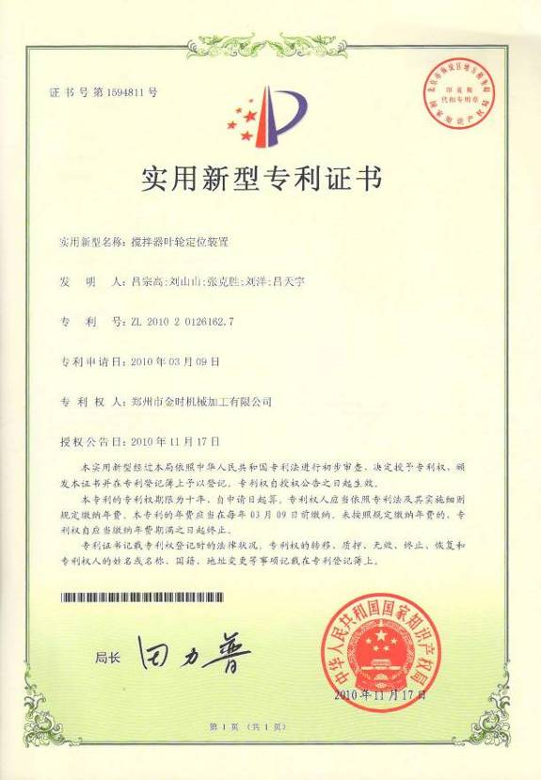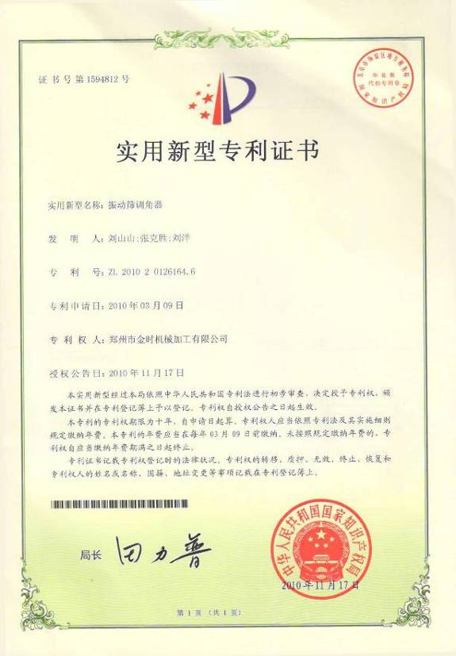

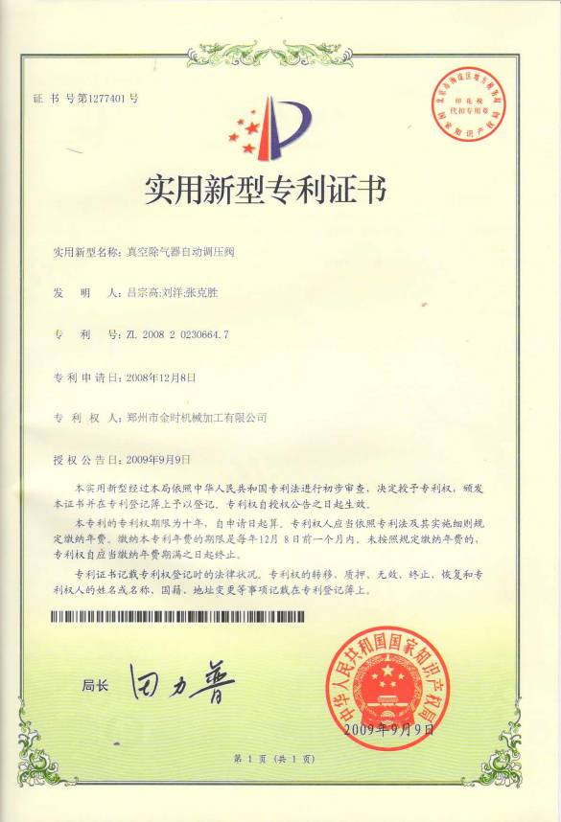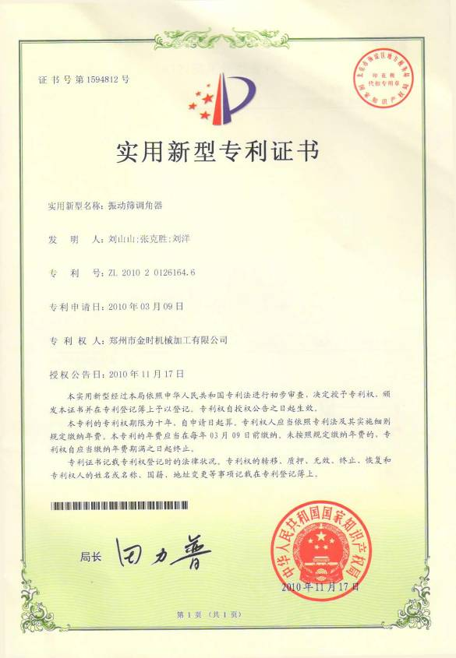

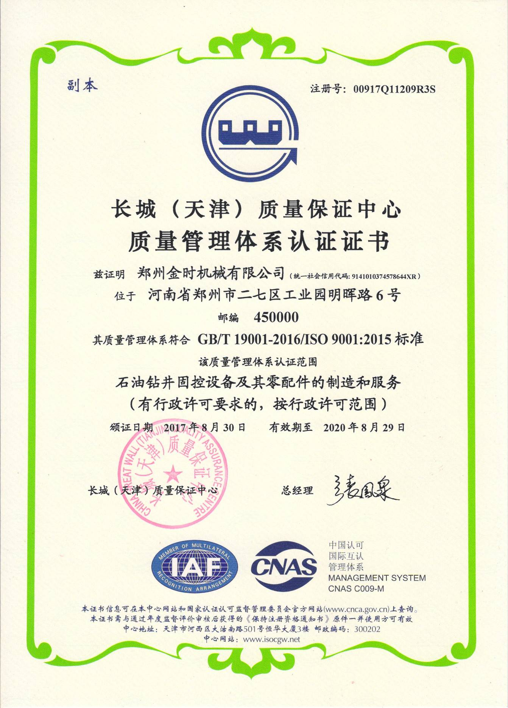

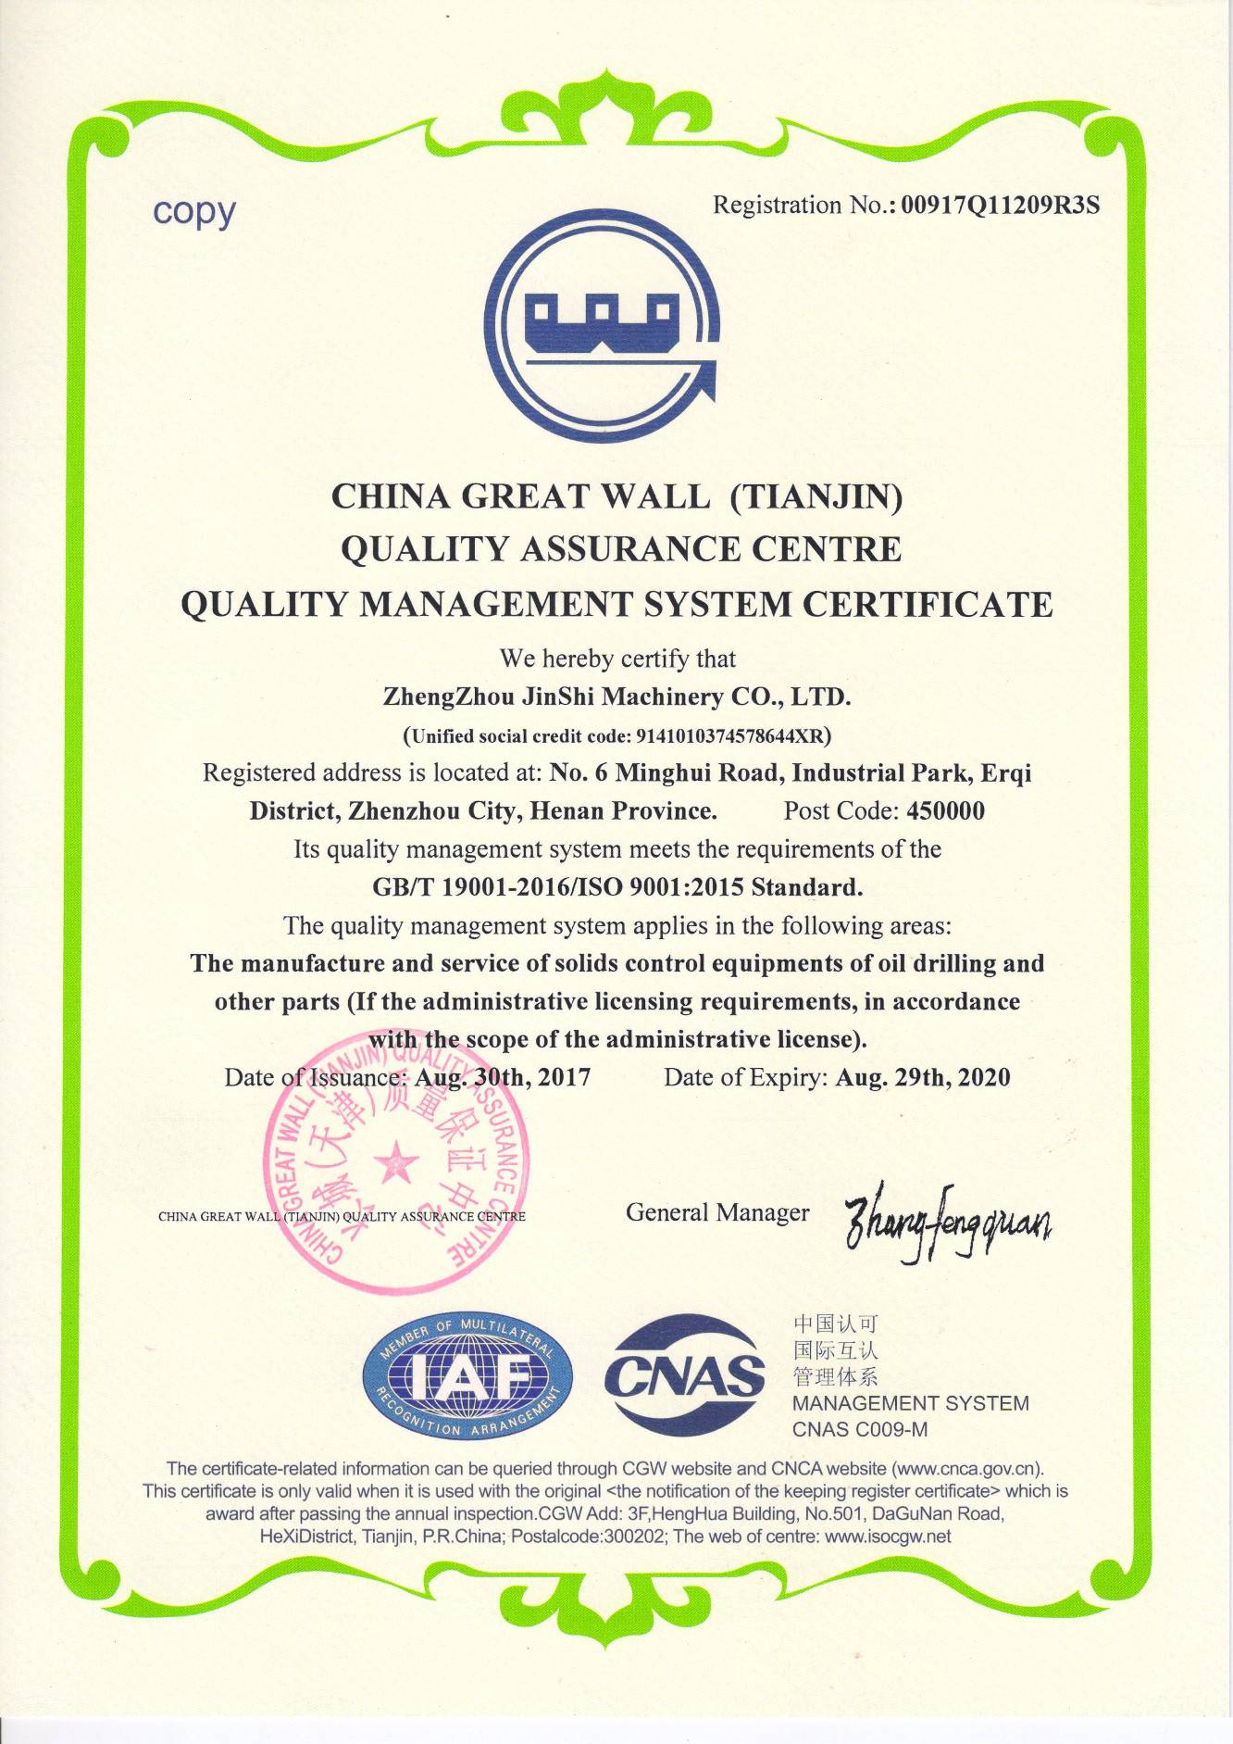

一、JXP系列离心式砂泵
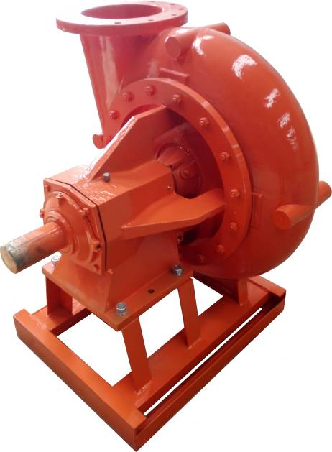
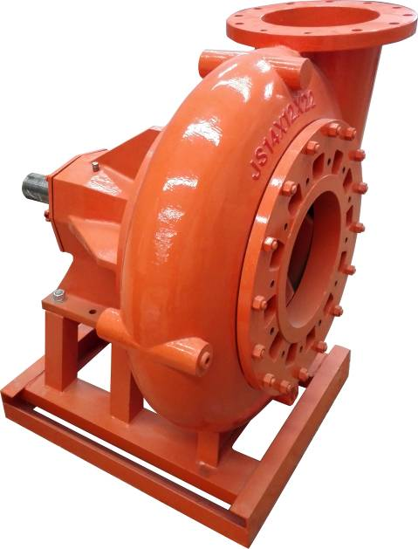
JXP Series Centrifugal Sand Pump

JXP系列砂泵是一种适用于苛刻作业环境的大功率，高排量的重型泥浆泵。特别适合于输送大流量，含磨蚀性或腐蚀性的重泥浆。其中JXP14×12×22 和JXP12×10×23输送量可以达到3000-7500加仑/分钟，扬程可达75-410英尺。
其紧凑的外形尺寸，使得JXP系列砂泵更适用于安装空间有限的车载环境，便于泵的移动和固定。
The JXP is ideally suited for pumping high volumes of heavy slurries that are abrasive, corrosive, or just plain tough to pump. The JXP14×12×22 and JXP12×10×23 can deliver flow rates from 3000 - 7500 gpm at 75 - 410 feet of head at low speeds.
The compact overall dimensions of the JXP make it an excellent choice for high volume mobile and stationary applications where a small footprint is critical.

典型应用
Typical Applications
• 压裂混合 • 纸浆加工
• Frac blending • Paper pulp processing
• 采石泥浆 • 砂浆
• Quarry slurries • Sand slurries
• 城市污水 • 矿渣
• Sewage • Slag
• 增压泵 • 废弃泥浆
• Supercharger pumps • Wast slurries
二、JDSB系列离心式砂泵
JDSB Series Centrifugal Sand Pump
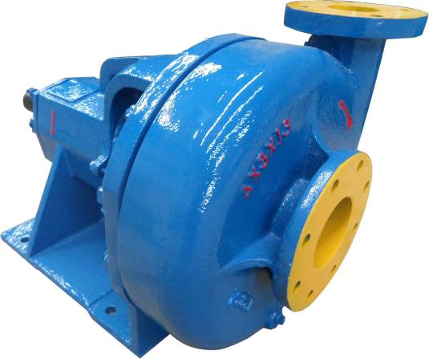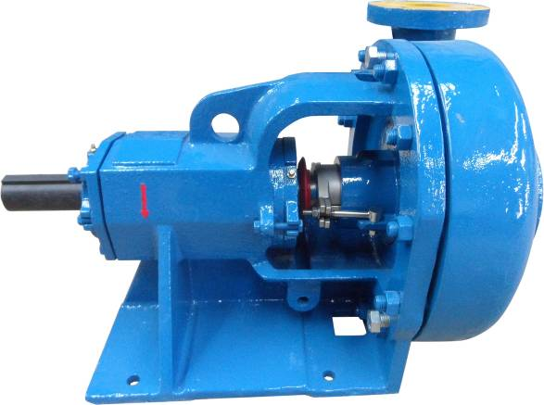
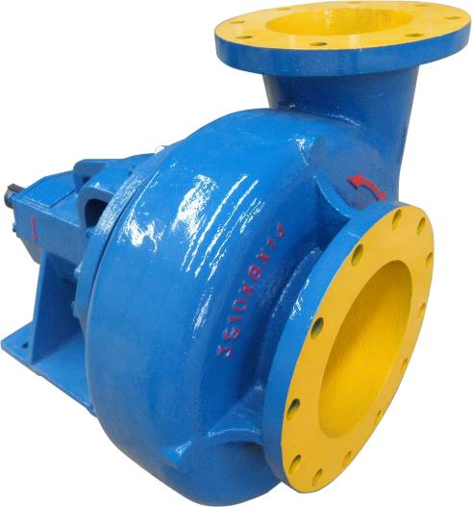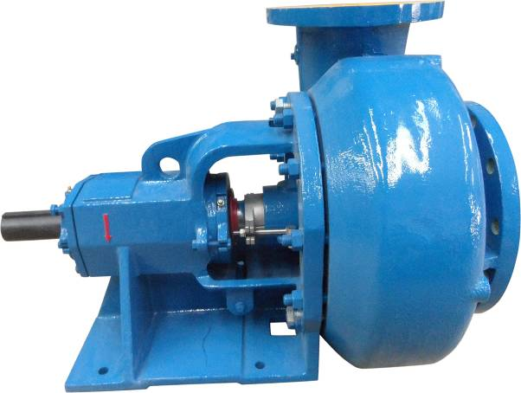
JDSB系列离心式砂泵不但具有JSB系列离心泵的优点，而且设计更紧凑，适应性更强，可以由液压马达来驱动。所以还可以用在油田的压列车、混砂车上。除了设计形状和轴外，其它零部件都是和JSB系列离心泵通用的。它的外形尺寸和轴都比普通泵短4英寸，当装备空间有限的时候，JDSB离心泵就是最佳的选择。
JDSB series centrifugal sand pump includes virtually all of the features of the JSB series pumps.JDSB series pumps are more compact in design and can be adapted for hydraulic motor drive.These features make .JDSB series pump ideal for use in applications such as oilfield frac trucks as well as blending and pump charging for water well drilling applications.All parts for these pumps are identical to the JDSB series pump except for the frame and shaft.The frame and shaft have been shortened 4" to reduce the length of the pump.When space is a premium and prime mover options are limited, the JDSB series pump is the pump of choice.
型号 Model | JDSB10×8×14 | JDSB8×6×14 | JDSB8×6×11 | JDSB6×5×14 | JDSB6×5×11 | JDSB5×4×14 | JDSB4×3×13 | JDSB3×2×13
排量  Discharge  capacity | 260～300 m³/h | 240～260 m³/h | 220～240 m³/h | 200～220 m³/h | 120～200 m³/h | 80～120 m³/h | 60～80 m³/h | 50～60m³/h
扬程  Pumping head | 28~33 | 28～33m | 24～28m | 24～28m | 24～28m | 24～28m | 22～28m | 22～28m
效率 Efficiency | 65% | 65% | 65% | 65% | 65% | 65% | 65% | 65%
电机功率  Motor power | 75/90 kW | 55/75 kW | 37/45 kW | 37/45/55 kW | 30/37/45 kW | 18.5/22/30 kW | 11/15 kW | 7.5/11 kW
电机转速  Motor speed | 1450/1750rpm | 1450/1750rpm | 1450/1750rpm | 1450/1750rpm | 1450/1750rpm | 1450/1750rpm | 1450/1750rpm | 1450/1750rpm
进口直径  Inlet diameter | 10″ | 8″ | 8″ | 6″ | 6″ | 5″ | 4″ | 3″
出口直径  Outlet diameter | 8″ | 6″ | 6″ | 5″ | 5″ | 4″ | 3″ | 2″
质量 Weight | 320kg | 275kg | 260kg | 250kg | 240kg | 230kg | 205kg | 195kg
外形尺寸,mm  Overall  dimension | 857×661×645 | 846×638×639 | 846×608×608 | 814×548×549 | 813×508×511 | 782×511×520 | 747×495×491 | 729×481×491

三、JSB10×8×14离心式砂泵
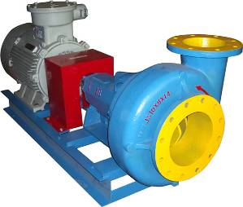
JSB10×8×14 Centrifugal Sand Pump
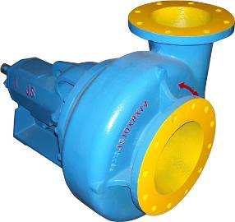
JSB10×8×14离心式砂泵主要是用来给油田钻机的循环固控系统配套，其作用是给除砂器、除泥器、混浆器等提供具有一定排量和压力的钻井液，以保证这些设备高效工作。该泵的进出口尺寸大，适适应于输送密度大于2的钻井液。
JSB10×8×14 centrifugal sand pump is mainly supplied to solids control circulating system of oilfiel drill rig,and be used to offer drilling fluid with certain volume and pressure to desander,desilter or mixer.It is especially suitable for the drilling engineering with drilling fluid being more density than 2,because of the big inlet and outlet dimension.
主要技术参数Main Technical Parameters
型号 Model | JSB10×8×14
排量Discharge capacity | 260~300m³/h
扬程 Pump Head | 33 m
效率 Efficiency | 65%
电机功率 Motor power | 75/90 kW
电机转速 Motor speed | 1450/1750(60Hz) rpm
进口直径Inlet diameter | 10″
出口直径Outlet diameter | 8″
质量 Weight | 1060/1140kg
外形尺寸Overall dimension，mm | 2007×701×950/2065×701×1015
四、JSB8×6×14离心式砂泵
JSB8×6×14 Centrifugal Sand Pump
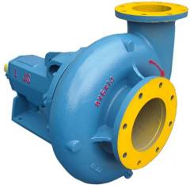
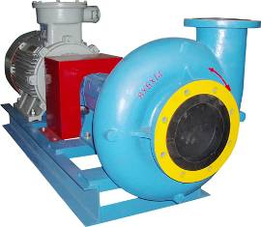
JSB8×6×14离心式砂泵主要是用来给油田钻机的循环固控系统配套，其作用是给除砂器、除泥器、混浆器等提供具有一定排量和压力的钻井液，以保证这些设备高效工作。该泵适合于4000～7000m钻机配套使用
JSB8×6×14 centrifugal sand pump is mainly supplied to solids control circulating system of oilfiel drill rig,and be used to offer drilling fluid with certain volume and pressure to desander,desilter or mixer.It is especially suitable for the 4000~7000m drilling rig.
主要技术参数Main Technical Parameters
型号 Model | JSB8×6×14
排量Discharge capacity | 240~260m³/h
扬程 Pump Head | 33 m
效率 Efficiency | 65%
电机功率 Motor power | 55/75 kW
电机转速 Motor speed | 1450/1750(60Hz)rpm
进口直径Inlet diameter | 8″
出口直径Outlet diameter | 6″
质量 Weight | 840/1035kg
外形尺寸Overall dimension，mm | 1927×655×880/1993×680×950
五、JSB8×6×11离心式砂泵
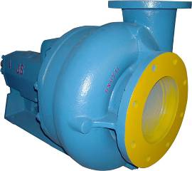
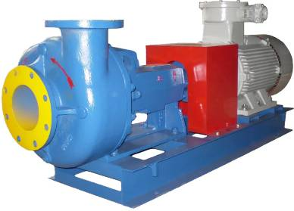
JSB8×6×11 Centrifugal Sand Pump

JSB8×6×11离心式砂泵主要是用来给油田钻机的循环固控系统配套，其作用是给除砂器、除泥器、混浆器等提供具有一定排量和压力的钻井液，以保证这些设备高效工作。适合于2500～4000m钻机配套使用
JSB8×6×11 centrifugal sand pump is mainly supplied to solids control circulating system of oilfiel drill rig,and be used to offer drilling fluid with certain volume and pressure to desander,desilter or mixer.It is especially suitable for the 2500~4000m drilling rig.
主要技术参数Main Technical Parameters
型号 Model | JSB8×6×11
排量Discharge capacity | 220～240m³/h
扬程 Pump Head | 28 m
效率 Efficiency | 65%
电机功率 Motor power | 37/45 kW
电机转速 Motor speed | 1450/1750(60Hz)rpm
进口直径Inlet diameter | 8″
出口直径Outlet diameter | 6″
质量 Weight | 700/755kg
外形尺寸Overall dimension，mm | 1855×648×850/1880×648×850
六、JSB6×5×14离心式砂泵
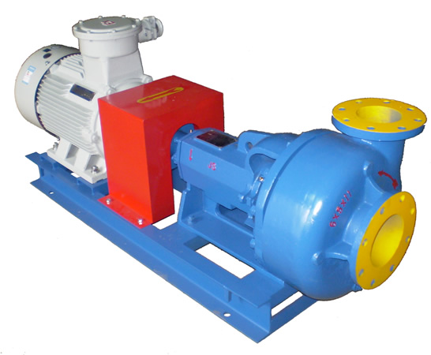
JSB6×5×14 Centrifugal Sand Pump

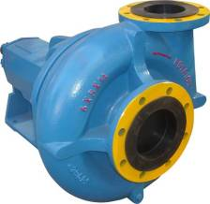

JSB6×5×14离心式砂泵主要是用来给油田钻机的循环固控系统配套，其作用是给除砂器、除泥器、混浆器等提供具有一定排量和压力的钻井液，以保证这些设备高效工作。适合于2000～3000m钻机配套使用
JSB6×5×14 centrifugal sand pump is mainly supplied to solids control circulating system of oilfiel drill rig,and be used to offer drilling fluid with certain volume and pressure to desander,desilter or mixer.It is especially suitable for the2000~3000m drilling rig.
主要技术参数Main Technical Parameters
型号 Model | JSB6×5×14
排量Discharge capacity | 200～220m³/h
扬程 Pump Head | 28 m
效率 Efficiency | 65%
电机功率 Motor power | 37/45/55 kW
电机转速 Motor speed | 1450/1750(60Hz)rpm
进口直径Inlet diameter | 6″
出口直径Outlet diameter | 5″
质量 Weight | 665/720/795kg
外形尺寸Overall dimension，mm | 1823×585×850  /1848×585×850/1902×600×880
七、JSB6×5×11、JSB5×4×14离心式砂泵
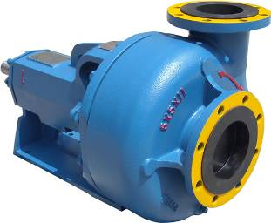
JSB6×5×11、JSB5×4×14 Centrifugal Sand Pump
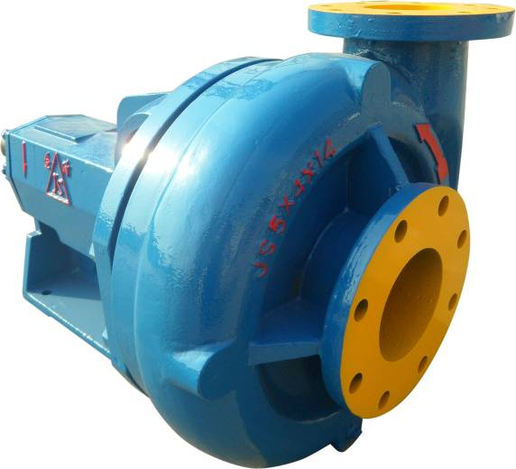 JSB6×5×11、JSB5×4×14离心式砂泵主要是用来给油田钻机的循环固控系统配套，其作用是给除砂器、除泥器、混浆器等提供具有一定排量和压力的钻井液，以保证这些设备高效工作。一般用于车装钻机或小型钻机的配套
JSB6×5×11、JSB5×4×14 centrifugal sand pump is mainly supplied to solids control circulating system of oilfiel drill rig,and be used to offer drilling fluid with certain volume and pressure to desander,desilter or mixer.It is especially suitable for truck-mounted drilling rigs or pocket drilling rigs.
主要技术参数Main Technical Parameters
型号 Model | JSB6×5×11 | JSB5×4×14
排量Discharge capacity | 120～200m³/h | 80～120 m3/h
扬程 Pump Head | 28 m | 28m
效率 Efficiency | 65% | 65%
电机功率 Motor power | 30/37/45 kW | 18.5/22/30 kW
电机转速 Motor speed | 1450/1750(60Hz)rpm | 1450/1750(60Hz)rpm
进口直径Inlet diameter | 6″ | 5″
出口直径Outlet diameter | 5″ | 4″
质量 Weight | 620/655/715 kg | 525/535/615kg
外形尺寸  Overall dimension，mm | 1762×522×814  /1822×585×850  /1847×585×850 | 1643×502×714  /1731×514×814  /1731×514×814
八、JSB4×3×13离心式砂泵
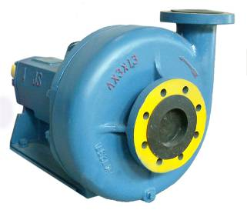
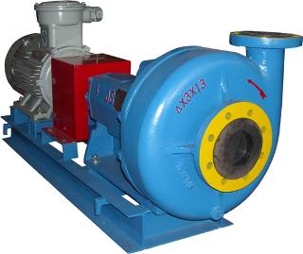
JSB4×3×13 Centrifugal Sand Pump

JSB4×3×13离心式砂泵主要是用来给油田钻机的循环固控系统配套，其作用是和计量罐配套，给井筒里灌注钻井液，或作为循环罐之间的倒浆使用。
JSB4×3×13 centrifugal sand pump mainly supplies to solids control circulating system of oilfield drill rig,and be used to fill drilling fluid to mineshaft, or used to deliver drilling fluid between circulating tanks.

主要技术参数Main Technical Parameters
型号 Model | JSB4×3×13
排量Discharge capacity | 60~80m³/h
扬程 Pump Head | 28 m
效率 Efficiency | 65%
电机功率 Motor power | 11/15 kW
电机转速 Motor speed | 1450/1750(60Hz)rpm
进口直径Inlet diameter | 4″
出口直径Outlet diameter | 3″
质量 Weight | 435/450kg
外形尺寸Overall dimension，mm | 1531×495×674/1571×495×674
九、JSB3×2×13离心式砂泵
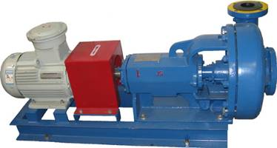
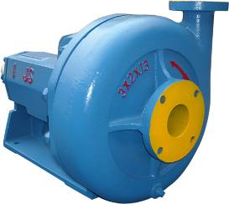
JSB3×2 ×13 Centrifugal Sand Pump

JSB3×2×13离心式砂泵主要是用来给油田钻机的循环固控系统配套，其作用是适应于各型钻机配套的清水泵。
JSB3×2×13 centrifugal sand pump mainly supplies to solids control circulating system of oilfield drill rig,and be used to fill drilling fluid to mineshaft, or used to deliver drilling fluid between circulating tanks.

主要技术参数Main Technical Parameters
型号 Model | JSB3×2×13
排量Discharge capacity | 50~60m³/h
扬程 Pump Head | 28m
效率 Efficiency | 65%
电机功率 Motor power | 7.5/11 kW
电机转速 Motor speed | 1450/1750(60Hz)rpm
进口直径Inlet diameter | 3″
出口直径Outlet diameter | 2″
质量 Weight | 365/420kg
外形尺寸Overall dimension，mm | 1388×482×609/1513×482×674

十、JZS系列直线振动筛
JZS Series Linear Motion Shale Shaker
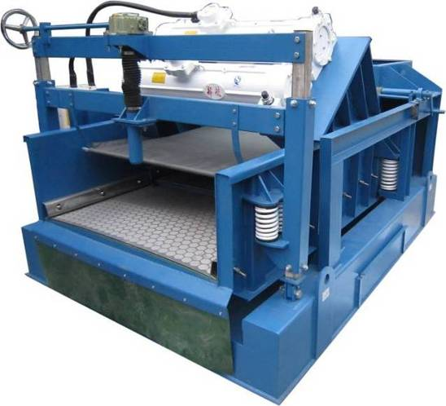
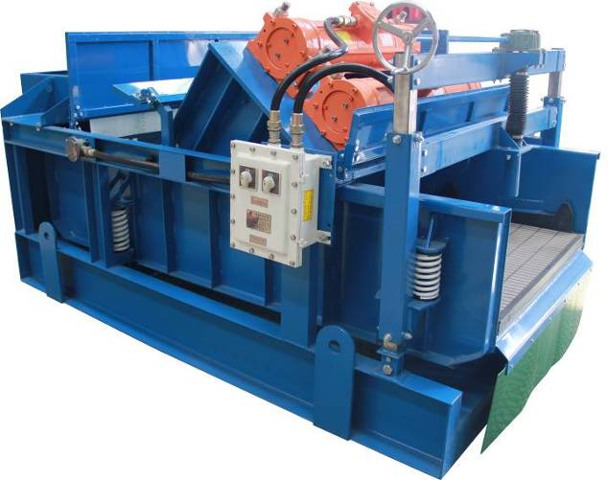

我公司的钻井液振动筛(配长杆型电机)吸取了国外同类产品的设计经验,并含有数项专有技术。其运动轨迹有直线平动和椭圆平动两种。
该筛具有振动强度高、处理能力强、可不停机调整筛床角度、结构简单紧凑、性能优异可靠、筛网及电机使用寿命长、性能价格比高等特点。
The shale shakers were solely designed and manufactured by our company but with the advantages of same international well-known products，containing more than one patents
The shale shakers being provided with high vibration intensity , adjustable-pitch ,compact, reliable ,behavior and cost effective ,is known as a competitive product in the international market.
主要技术参数Main Technical Parameters
型 号 Model | JZS280-3P | JZS270-4P | JZS240-3P | JZS220-3P | JZS180-2P
电机功率  Motor power | 2×2.2 kW | 2×2.2 kW | 2×2.2 kW | 2×2.2 kW | 2×1.3 kW
筛网面积  Screen area(m²) | 3×0.833×1.15 | 4×0.585×1.165 | 3×0.7×1.15 | 3×0.7×1.05 | 2×0.833×1.15
振动强度  Shaking intensity（g） | 7.2 g | 7.2 g | 7.2 g | 7.2 g | 7.2 g
处理量  Discharge capacity | 42 l/s | 40 l/s | 35 l/s | 30 l/s | 26 l/s
筛箱调整角  Adjustable range | -2°～+6° | -2°～+6° | -2°～+6° | --2°～+6° | -2°～+6°
外形尺寸  Overall dimension,mm | 3140×1980×1540 | 2970×1980×1530 | 2700×1980×1540 | 2700×1900×1540 | 2300×1940×1300
质量Weight | 2000 kg | 2000kg | 1900kg | 1700 kg | 1200kg

十一、JZS系列椭圆振动筛
JZS Series Elliptical Motion Shale Shaker
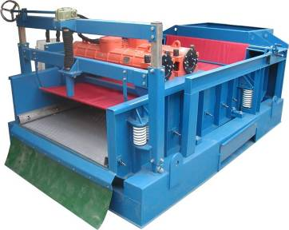
我公司的钻井液振动筛(配长杆型电机)吸取了国外同类产品的设计经验,并含有数项专有技术。其运动轨迹有直线平动和椭圆平动两种。
该筛具有振动强度高、处理能力强、可不停机调整筛床角度、结构简单紧凑、性能优异可靠、筛网及电机使用寿命长、性能价格比高等特点。
The shale shakers were solely designed and manufactured by our company but with the advantages of same international well-known products，containing more than one patents
The shale shakers being provided with high vibration intensity , adjustable-pitch ,compact, reliable ,behavior and cost effective ,is known as a competitive product in the international market.
主要技术参数Main Technical Parameters
型 号 Model | JZS280-3P | JZS270-4P | JZS240-3P | JZS220-3P | JZS180-2P
电机功率  Motor power | 2×2.2 kW | 2×2.2 kW | 2×2.2 kW | 2×2.2 kW | 2×1.3 kW
筛网面积  Screen area(m²) | 3×0.833×1.15 | 4×0.585×1.165 | 3×0.7×1.15 | 3×0.7×1.05 | 2×0.833×1.15
振动强度  Shaking intensity（g） | 7.2 g | 7.2 g | 7.2 g | 7.2 g | 7.2 g
处理量  Discharge capacity | 42 l/s | 40 l/s | 35 l/s | 30 l/s | 26 l/s
筛箱调整角  Adjustable range | -2°～+6° | -2°～+6° | -2°～+6° | --2°～+6° | -2°～+6°
外形尺寸  Overall dimension,mm | 3140×1980×1540 | 2970×1980×1530 | 2700×1980×1540 | 2700×1900×1540 | 2300×1940×1300
质量Weight | 2000 kg | 2000kg | 1900kg | 1700 kg | 1200kg

十二、JZQ系列钻井液清洁器（一体机）
JZQ Series Drilling Liquid Cleaner
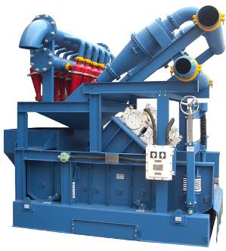
钻井液清洁器是集除砂清洁器、除泥清洁器、振动筛于一体的钻井液固控设备。它综合了以上三种设备的性能，具有处理量大、处理速度快、动能损耗少、占用空间小等优点，尤其在国际钻井市场上倍受欢迎。
The drilling liquid cleaner is fixed drilling liquid solids control equipment consisting of desander,desilter and shale shaker. It integrates the performance of aforesaid three equipments, featuring large disposal capacity, rapid treatment speed, less energy consumption, occupying small space, etc. It receives the most welcome in the international drilling market.
主要技术参数Main Technical Parameters
型号Model | JZQ300×2  /100×12 | JZQ300×2  /100×14 | JZQ300×2  /100×16 | JZQ250×2  /100×12 | JZQ250×2  /100×16 | JZQ250×2  /100×16
除砂器参数Desander parameters
除砂器锥筒  Hydrocyclone | 12″×2 |  |  | 10″×2
工作压力  Working pressure | 0.2~0.45 MPa
处理量Capacity | 240 m³/h |  |  | 200 m³/h
分离点Seperation size | 44~74 μm
除泥器参数Desilter parameters
除泥器锥筒  Hydrocyclone | 4″×12 | 4″×14 | 4″×16 | 4″×12 | 4″×14 | 4″×16
工作压力  Working pressure | 0.2~0.45 MPa
处理量Capacity | 200 m³/h | 220 m³/h | 240 m³/h | 200 m³/h | 220 m³/h | 240 m³/h
分离点Seperation size | 20~44 μm
进液管通径Inlet diameter | 6″ (150mm)
排液管通径Outlet diameter | 8″ (200mm)
振动筛型号  Supporting shaker | JZS220-3P / JZS240-3P / JZS280-3P
质量Weight | 2600kg / 2750kg / 2950 kg
外形尺寸Overall dimension | 2700×2550×2600/2700×2550×2600/3140×2550×2600mm
十三、JZQJ双锥筒除砂器
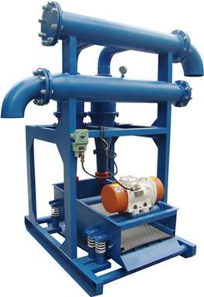
JZQJ Double Hydrocyclone Desander
除砂器是钻井作业中的第二级固控设备，主要用来除去钻井液中粒径为40－74µm的有害固相颗粒。利用离心沉降工作原理，悬浮颗粒受到离心加速度的作用后可从液体中分离出来。
目前除砂器有三种型号JZQJ300×2、JZQJ250×2、JZQJ200×2和JZQJ300×1、 JZQJ250×1、JZQJ200×1，前者适用于3000米以上的钻机，后者适用于3000米以下的小型钻机和修井钻机。
As a solids control equipment of the second stage in drilling operation, desander is used to remove harmful solid particles of 40-74µm in drilling liquid.Suspending particles can be separated from the liquid under the centrifugal acceleration, by use of working principle of centrifugal subsidence.
At present time, six types,JZQJ300×2,JZQJ250×2, JZQJ200×2 and JZQJ300×1, JZQJ250×1, JZQJ200×1are available. The former applies to over 3000-meter-long drills, and the latter applies to small drills of less than 3000 meters and service rig.
主要技术参数Main Technical Parameter
型号 Model | JZQJ300×2 | JZQJ250×2 | JZQJ200×2
旋流器公称直径  Hydrocyclone diameter | 300mm | 250mm | 200mm
工作压力Working pressure | 0.2～0.45MPa | 0.2～0.45MPa | 0.2～0.45MPa
处理量 Capacity | 240 m³/h | 200 m³/h | 160 m³/h
筛网尺寸 Screen size | 1240×585 mm | 1240×585 mm | 1240×585 mm
筛网规格 Screen spec | 120-200 目 | 120-200 目 | 120-200 目
进液管直径 Inlet diameter | 6″ | 6″ | 3″
排液管直径 Outlet diameter | 8″ | 8″ | 6″
电机功率 Motor power | 0.5 kW | 0.5 kW | 0.5 kW
质量Weight | 780 kg | 740 kg | 700 kg
外形尺寸Overall dimensions | 1630×2018×2280mm | 1630×2018×2215mm | 1630×1875×2045mm
十四、JZQJ单锥筒除砂器
JZQJ Single Hydrocyclone Desander
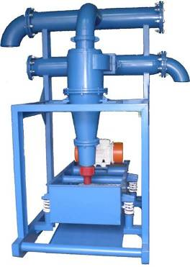
除砂器是钻井作业中的第二级固控设备，主要用来除去钻井液中粒径为44－74µm的有害固相颗粒。利用离心沉降工作原理，悬浮颗粒受到离心加速度的作用后可从液体中分离出来。
目前除砂器有六种型号JZQJ300×2、JZQJ250×2、JZQJ200×2和JZQJ300×1、 JZQJ250×1、JZQJ200×1，前者适用于3000米以上的钻机，后者适用于3000米以下的小型钻机和修井钻机。
As a solids control equipment of the second stage in drilling operation, desander is used to remove harmful solid particles of 44-74µm in drilling liquid.Suspending particles can be separated from the liquid under the centrifugal acceleration, by use of working principle of centrifugal subsidence.
At present time, six types,JZQJ300×2,JZQJ250×2, JZQJ200×2 and JZQJ300×1, JZQJ250×1, JZQJ200×1are available. The former applies to over 3000-meter-long drills, and the latter applies to small drills of less than 3000 meters and service rig.
主要技术参数Main Technical Parameter
型号 Model | JZQJ300×1 | JZQJ250×1 | JZQJ200×1
旋流器公称直径  Hydrocyclone diameter | 300mm | 250mm | 200mm
工作压力Working pressure | 0.2～0.45MPa | 0.2～0.45MPa | 0.2～0.45MPa
处理量 Capacity | 120m³/h | 100m³/h | 80m³/h
筛网尺寸 Screen size | 1240×585 mm | 1240×585 mm | 1240×585 mm
筛网规格 Screen spec | 120-200 目 | 120-200 目 | 120-200 目
进液管直径 Inlet diameter | 6″ | 6″ | 3″
排液管直径 Outlet diameter | 8″ | 8″ | 6″
电机功率 Motor power | 0.5 kW | 0.5 kW | 0.5 kW
质量Weight | 680kg | 640kg | 620kg
外形尺寸Overall dimensions | 1630×2018×2280mm | 1630×2018×2215mm | 1630×1875×2045mm
十五、JZQJ系列除泥清洁器
JZQJ Series Desilter
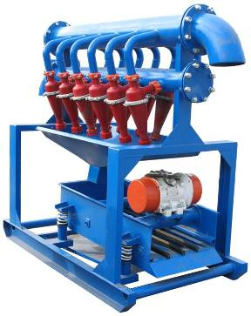
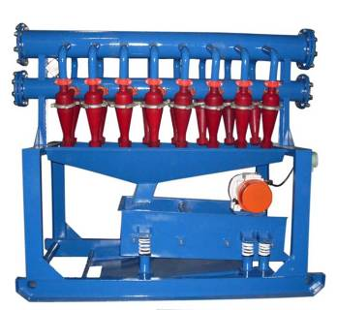

除泥清洁器是钻井作业中的第三级固控设备，主要用来除去钻井液中粒径为20－44 µm的固相颗粒。在多年的实践应用基础上，经过多次革新，该型除泥清洁器技术性能可靠，处理效果好，水力旋流器使用寿命长，性能稳定，适用于油田各类型钻机配套使用。
水力旋流器进出口采用快速连接，非常便于更换与维护。
As a solids control equipment of the third stage in drilling operation, desilter is used to remove solid particles of 20－44 µm in drilling liquid. The desilter of this type that has been reformed many times on the applications for years is reliable in technical performance and provides very good treatment results. Its water cyclone is of long service life and stable performance. It is applicable to various kinds of drills in the oilfields.
The inlet and outlet of water cyclone can be connected very quickly, which is convenient for replacement and maintenance.

主要技术参数Main Technical Parameter
型号Model | JZQJ100×10 | JZQJ100×12 | JZQJ100×14 | JZQJ100×16
旋流器直径  Hydrocyclone diameter | 100mm | 100mm | 100mm | 100mm
工作压力Working pressure | 0.2～0.45MPa | 0.2～0.45MPa | 0.2～0.45MPa | 0.2～0.45MPa
处理量Capacity | 120-160 m³/h | 160-200 m³/h | 200-220 m³/h | 200-240 m³/h
筛网尺寸 Screen size | 1240×585 mm | 1240×585 mm | 1240×585 mm | 1240×585 mm
筛网规格 Screen spec | 120-200 目 | 120-200 目 | 120-200 目 | 120-200 目
进液管通径 Inlet diameter | 6″ | 6″ | 6″ | 6″
排液管通径 Outlet diameter | 8″ | 8″ | 8″ | 8″
电机功率 Motor power | 0.5 kW | 0.5 kW | 0.5 kW | 0.5 kW
质量 Weight | 680kg | 720kg | 740kg | 780kg
外形尺寸Overall dimension | 2310×1136×2085 | 2546×1136×2085 | 2646×1136×2085 | 2866×2018×2085

十六、JZCQ系列真空除气器
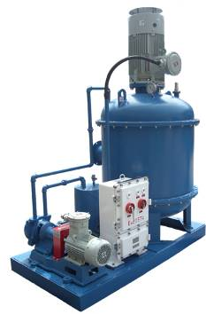
JZCQ Series Vacuum Degasser
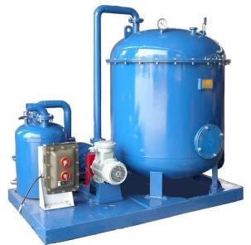

真空除气器是专门处理气侵钻井液的固控设备，可迅速除去钻井液中的侵入气体，恢复钻井液比重，稳定钻井液性能。它是探井、超深井、欠平衡井钻井工程中不可缺少的设备，适用于配套各类钻井液循环净化系统。
该除气器采用水环式真空泵，等温工作状态，适用于抽吸易燃易爆气体，安全性能可靠。
气水分离器结构设计合理，可保证气－水有效分离，保持排气管始终畅通。
New Type Vacuum Degasser is solids control equipment for treatment of gas cut drilling liquid. It can get rid of incursive gas quickly in drilling liquid to recover specific gravity of drilling liquid and stabilize its performance. It is indispensable equipment in exploratory well and drilling in ultradeep well and under-balanced drilling. It is applicable to various kinds of drilling liquid cycling purification system.
This degasfier is equipped with water-ring vacuum pump and constant temperature working status. It is suitable to suck flammable and combustible gas, with safe and reliable performance.
The structure of gas-water separator is reasonably designed to assure of effective separation of gas and water and free-flowing of vent pipe.

主要技术参数Main Technical Parameter
型号 Model | JZCQ-240 | JZCQ360-180 | JZCQ-300
处理量  Discharge capacity | 200～260m³/h | 300～360m³/h | 280～320m³/h
真空度Vacuum degree | 280～400mmHg | 400～550mmHg | 380～500mmHg
除气效率Efficiency | ≥95% | ≥95% | ≥95%
主电机功率  Main motor power | 15kW | 22kW
真空泵电机功率  Vacuum pump motor power | 2.2 kW/3 kW（60Hz） | 4 kW/5.5 kW（60Hz） | 3 kW/4 kW（60Hz）
进液管通径  Inlet diameter | 5″ | 6″ | 8″
排液管通径  Outlet diameter | 6″ | 8″ | 8″
质量Weight | 1150kg | 1470kg | 1300kg
外形尺寸  Overall dimension | 1990×1100×2300mm | 2200×1220×2400mm | 2500×1400×2100mm

十七、LW系列离心机
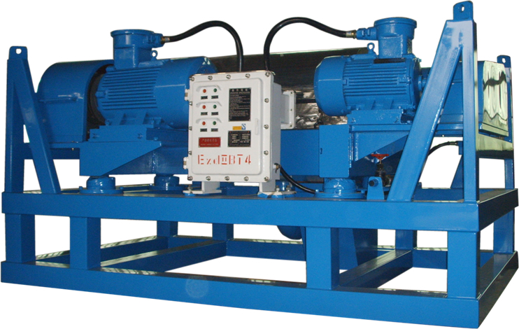
LW Series Centrifuge
离心机是处理钻井液中超细有害固相的关键设备，可分离和回收粒度大于5µm的固相，迅速恢复钻井液的密度等，从而提高钻井速度，是打深井和水平井理想的钻井液净化设备。本机主要用于控制钻井液的密度、粘度，降低钻井液的固相含量，清除有害固相、回收重晶石，以及对旋流器底进行二次回收以保证钻井液的优良性能，提高钻井速度。
Centrifuge is the key equipment in treatment of harmful superfine solidoid in drilling liquid. It can separate and recycle the solidoid with the particle of bigger than 5µm and recover the density of drilling liquid so as to increase drilling speed. It is ideal drilling liquid purification equipment for drilling a deep well and a horizontal well. This equipment is mainly used to control density, viscosity of drilling liquid, minimize solidoid content in drilling liquid, clear away harmful solidoid and recover barite, and provide secondary recovery to swirler bottom in order to assure of excellent performance of drilling liquid and increase drilling speed.
主要技术参数Main Technical Parameters
型号 Model | GLW355×1280-N | GLW450×1260-N | LW500×1000-N | GLW500×1250-N
转鼓直径(mm)  Diametet of Revolving Drum | 355 | 450 | 500 | 500
转鼓长度(mm)  Length of Revolving Drum | 1280 | 1260 | 1000 | 1250
最高转速(r/min)  Maximum speed | 2500~3200 | 2400~3000 | 1600~1800 | 2400~2800
最大处理量(m³/h) Capacity | 10~20 | 30-40 | 40~60 | 35~50
最小分离点(μm)  Min separating point | 2 | 2 | 5 | 3
电机功率(kW) Motor power | 22+7.5 | 37+7.5 | 30+7.5 | 37+11
质量(kg) Weight | 2200 | 3000 | 2800 | 3500
外型尺寸(mm)  Overall dimension | 3100×1470×1070 | 3100×1500×1070 | 2750×1580×1400 | 3060×1670×1400
类型  Type | 高速防爆双变频  Explosion-proof high-speed dual-frequency | 高速防爆双变频  Explosion-proof high-speed dual-frequency | 中速  Medium Speed | 高速防爆双变频  Explosion-proof high-speed dual-frequency
十八、JQB系列剪切泵
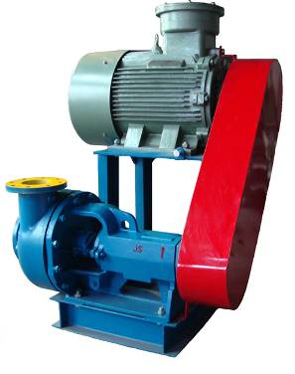
JQB Series Shearing Pump
JQB系列剪切泵主要用于油田化学药品的配制。本公司考虑到剪切泵工作环境恶劣，为延长其使用寿命，对关键配件的选购均有特殊要求。叶轮和剪切盘均采用优质不锈钢制造；独特的机械密封和进口油封，确保剪切泵的使用寿命长，泵效率高，油封无泄漏，工作可靠，维修方便，能够满足用户配制和处理高性能泥浆的要求。
JQB Series Shearing Pump is mainly used in preparations of chemical medicine of oilfield. In consideration of poor working conditions of shearing pump, in order to extend its service life, the company is very strict with and has very special requirements for purchasing of key components. The impellers and shearing plates are made from fine quality stainless steel; the unique mechanical sealing and imported oil seal assure shearing pump of long service life, high efficiency, no-leaking, reliability and convenience of maintenance. It can satisfies user’s requirements in making-up and treatment of high-performance mud.
主要技术参数Main Technical Parameter
型号 Model | JQB-80 | JQB-100 | JQB-120
处理量 Discharge capacity | 80 m³/h | 100 m³/h | 120m³/h
扬程 Pumping head | 36 m | 40 m | 45m
剪切效率 Shearing efficiency | 95% | 95% | 95%
电机功率 Motor power | 37 kW | 45 kW | 55 kW
叶轮转速Impeller speed | 2200rpm | 2200rpm | 2200rpm
进口直径 Inlet diameter | 6″ | 6″ | 6″
出口直径 Outlet diameter | 5″ | 5″ | 5″
质量 Weight | 700 kg | 760 kg | 850 kg
外形尺寸 Overall dimension | 1030×995×1440mm | 1030×995×1440mm | 1065×995×1470mm

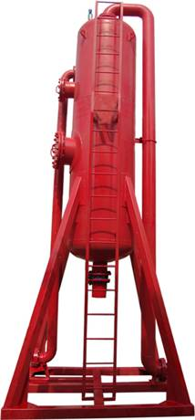
十九、JYQ系列液气分离器
JYQ Series Liquid－gas Separator
钻井液液－气分离器是对气侵钻井液进行初级脱气的固控设备，主要用来清除气侵钻井液中直径在φ3－φ25mm的大气泡。该液－气分离器采用封底式结构，具有结构简单，流程合理，处理量大，除气效率高，运输、安装、维护方便快捷等优点。
Liquid－gas separator of drilling liquid is solids control equipment used to provide pre-degassing to gas cut drilling liquid. It is mainly used to clear away big bubbles of φ3－φ25mm. The liquid gas separator adopts bottom-sealing structure. It features simple structure, reasonable flow, big disposal capacity, high degassing efficiency, convenient transportation, installation and service, etc.
主要技术参数Main Technical Parameter

1.0 MPa
型号 Model | JYQ-800-1 | JYQ-1000-1 | JYQ-1200-1
主体直径，mm  Main body diameter | 800 | 1000 | 1200
处理量，m³/h  Discharge capacity | 260 | 300 | 320
进液管直径，mm  Inlet diameter | 125/150 | 125/150 | 125/150
排液管直径，mm  Outlet diameter | 200/250 | 200/250 | 200/250
排气管直径，mm  Exhaust diameter | 200 | 200 | 200
工作压力，MPa  Working pressure | 1 | 1 | 1
质量，kg  Weight | 2100 | 2800 | 3200
外形尺寸，mm  Overall dimension | 1600×1600×5762 | 2000×2000×6500 | 2200×2200×6500

1.6MPa
型号 Model | JYQ-1000-1.6 | JYQ-1200-1.6
主体直径，mm  Main body diameter | 1000mm | 1200 mm
处理量，m³/h  Discharge capacity | 300 m³/h | 320 m³/h
进液管直径，mm  Inlet diameter | 125/150 | 125/150
排液管直径，mm  Outlet diameter | 200/250 | 200/250
排气管直径，mm  Exhaust diameter | 200 | 200
工作压力，MPa  Working pressure | 1.6 | 1.6
质量，kg  Weight | 3200kg | 3900kg
外形尺寸，mm  Overall dimension | 2200×2200×6500 | 2200×2200×6500

4.0MPa
型号 Model | JYQ-1000-4 | JYQ-1200-4
主体直径，mm  Main body diameter | 1000 | 1200
处理量，m³/h  Discharge capacity | 300 | 320
进液管直径，mm  Inlet diameter | 125/150 | 125/150
排液管直径，mm  Outlet diameter | 200/250 | 200/250
排气管直径，mm  Exhaust diameter | 200 | 200
工作压力，MPa  Working pressure | 4 | 4
质量，kg  Weight | 8000 | 9500
外形尺寸，mm  Overall dimension | 2300×2300×6500 | 2300×2300×6500

二十、JNJ系列搅拌器
JNJ Series Agitator
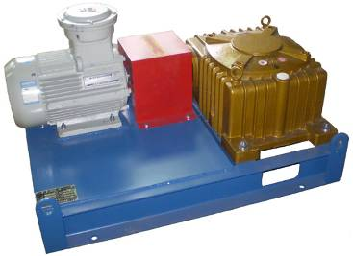
钻井液搅拌器的作用是为了保持钻井液的均匀性并使固相颗粒悬浮，而对钻井液进行连续可靠的搅拌。由于减速器采用蜗杆单级减速器，所以结构紧凑，质量轻，传动平衡，噪音低，传递效率大，搅拌能力强。
Drilling liquid agitator is used to provide continuous and reliable agitation of drilling liquid in order to retain uniformity of drilling liquid and keep solid particles suspending. It is of compact structure, light weight, transmission balance, low noise, high efficiency and strong capability, because the reducer adopts turbine worm single reduction gear.

主要技术参数Main Technical Parameter
型号Model | JNJ-5.5 | JNJ-7.5 | JNJ-11 | JNJ-15
电机功率 Motor power | 5.5 kW | 7.5 kW | 11 kW | 15 kW
电机转速  Rotate speed of motor | 1450/1750rpm | 1450/1750rpm | 1450/1750rpm | 1450/1750rpm
叶轮转速  Rotate speed of impeller | 60/70rpm | 60/70rpm | 60/70rpm | 60/70rpm
叶轮直径  Impeller diameter | 600/530mm | 800/700mm | 1000/900mm | 1000/900mm
轴长 Shaft length | 根据泥浆罐深度确定  According to the mud tank depth
质量 Weight | 310kg | 350kg | 500kg | 510kg
外形尺寸,mm  Overall dimension | 1015×700×550 | 1080×755×560 | 1260×810×640 | 1300×810×640

二十一、JSLH系列射流混浆装置
JSLH Series Jet Mixing Device
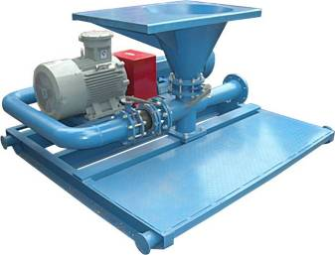
射流混浆装置是用来配制或增加钻井液总量，改变钻井液密度、粘度、失水等。使用该装置可以充分分散和混合钻井液材料。
射流混浆装置由一台砂泵和一台射流混浆器（或多台砂泵和射流混浆器）用管汇阀门联接安装在一个底座上组成的，具有运输、安装、维护方便等优点。
也可按照客户需要定制各种组合形式。
Jet mixing device is used to prepare or aggravate drilling fluid,change the density,viscosity,water loss of the drilling fluid.With the decive,the materials and agents can be mixed well.
The jet mixing device is comprised of one sand pump,one jet mixer(or several pumps and mixers) ,valves and manifold.convenient transporation,installation and service,etc.
We can offer various compoud type according to the customers’ requirements.
主要技术参数Main Technical Parameter
型号 Model | JSLH150-55 | JSLH150-45 | JSLH150-37
配套砂泵  Supporting pump | JSB8×6×14 | JSB8×6×11 | JSB6×5×11
电机功率  Motor power | 55kW | 45kW | 37kW
处理量  Discharge capacity | 240m³/h | 220m³/h | 200m³/h
工作压力  Working pressure | 0.25~0.6MPa | 0.25~0.6MPa | 0.25~0.6MPa
进液管通径  Inlet diameter | 8″ | 8″ | 6″
排液管通径  Outlet diameter | 6″ | 6″ | 6″
配料速度  Mixing speed | ≤100kg/min | ≤80kg/min | ≤60kg/min
质量 Weight | 1300kg | 1200kg | 1100kg
外形尺寸  Overall dimension | 2500×2300×1200mm | 2500×2300×1200mm | 2200×2200×1200mm
二十二、JSL系列射流混浆器
JSL Sereis Jet Mixer
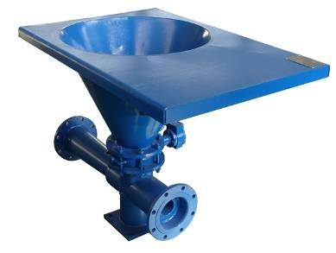
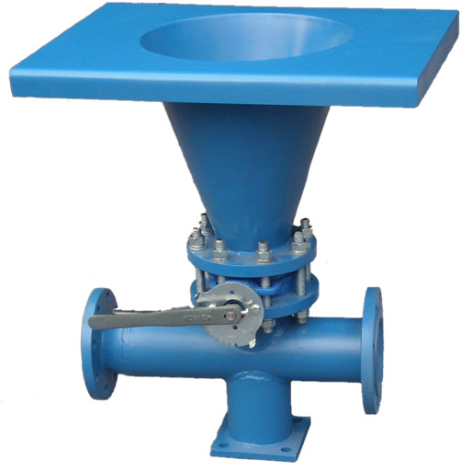
射流混浆器一般与剪切泵配合使用，主要用来混合钻井液中不易分散的化学药品。由于它的出口压力大，可以安装在泥浆循环罐罐面以下。
Jet mixer works generally together with shearing pump and is mainly used to mix chemical medicine which is not easily dispersed in drilling liquid. Due to high pressure at the outlet, it can be installed under level of mud circulation tank.
主要技术参数Main Technical Parameter
型号Model | JSL-100 | JSL-150
处理量 Discharge capacity | 100 m³/h | 200 m³/h
进口压力Inlet pressure | 0.25～0.6MPa | 0.25～0.6 MPa
出口压力Outlet pressure | 0.1～0.3MPa | 0.1～0.3 MPa
进口通径 Inlet diameter | 4″（3″） | 6″
出口通径 Outlet diameter | 4″ | 6″
质量 Weight | 100 kg | 130 kg
外形尺寸Overall dimension | 600×400×720mm | 1375×750×950mm
二十三、JXL－250旋流混浆器
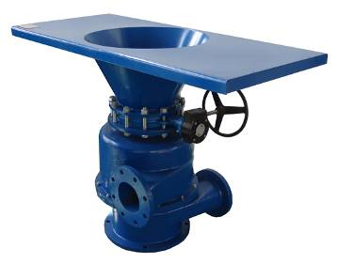
JXL－250 Vortex Mixer
旋流混浆器是将钻井液固相添加剂与钻井液均匀混合，适用于钻井液配制的基本设置。该混浆器采用旋流混合技术，可实现向钻井液中快速添加膨润土、重晶石等钻井液材料，以适应复杂钻井工艺的要求。该产品具有混合效果好、加料速度快、不易堵塞等特点。
Vortex mixer mixes solidoid additive with drilling liquid evenly. It is suitable to the basic equipment in configuration of equipments for drilling liquid. This mixer adopts rotational flow mixing technology, and can fill bentonite and barite, etc into drilling liquid quickly in order to be adapted to complicated drilling process. This product is of good mixing effect, quick filling of material, and no-blockage.

主要技术参数Main Technical Parameter
型号Model | JXL－250
处理量 Discharge capacity | 200～240 m³/h
进口压力 Inlet pressure | 0.25～0.6 MPa
出口压力 Outlet pressure | ≤0.04 MPa
进口通径 Inlet diameter | 6″
出口通径 Outlet diameter | 6″
质量 Weight | 480 kg
外形尺寸  Overall dimensions | 1500×700×1090 mm
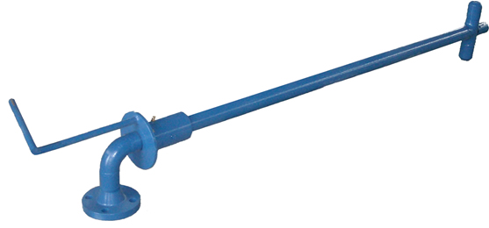
二十四、JNQ系列泥浆枪
JNQ Series Mud Gun
泥浆枪的作用是利用三缸泵或离心泵提供的一定压力来冲击循环罐底的沉淀物，再通过搅拌器的搅拌使钻井液均匀混合，还可以用于清洗罐底的沉砂。
The function of mud gun is striking the sediment at the bottom of circulation tank with certain pressure which supplied by triplex pump or centrifugal pump,and then mixing the drilling liquid evenly by agitation of the agitator.It also can be used to wash the sand setting of the tank.
主要技术参数Main Technical Parameters
型号 Model | JNQ-80-1 | JNQ-80-6.4 | JNQ-50-1 | JNQ-50-6.4
排量  Discharge capacity | 60 m³/h | 60 m³/h | 50 m³/h | 50 m³/h
公称直径 Nominal diameter | 80 mm | 80 mm | 50 mm | 50 mm
工作压力 Working pressure | ≤1 MPa | ≤6.4 MPa | ≤1 MPa | ≤6.4 MPa
转动范围Adjustable range | 0～330° | 0～330° | 0～330° | 0～330°
总长 Length | 根据泥浆罐深度确定  According to the mud tank depth
质量 Weight | 65kg | 90kg | 55kg | 85kg

二十五、泥浆循环罐
Mud circulation tank
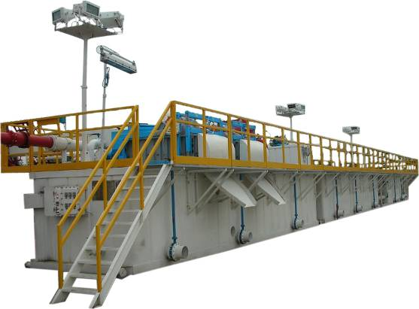
泥浆循环罐采用了楞板结构，“四级净化、全流程控制、全防爆电路”标准，深受井队欢迎。
Using the corrugated sheet structure,and with the “five stages purification,control of total access,total intrinsically safe circuit”,the mud circulation tank is well received by the drilling crew.
其主要特点：
The main features
(1) 罐体采用楞板结构，具有强度高、美观大方等优点，同时减少了罐体的自身质量；
With the corrugated sheet structure,the tank body has the advantage of high strength, elegant appearance,and reduce the weight of tank body.
(2) 固控设备布局合理，达到五级净化标准（粗筛、除气、除砂、除泥、离心），使泥浆性能得到进一步优化；
The solids control equipments are rationally distributed,and up to five stages purification(rough screening,degas,desand,desilt and centrifugation),and optimum the performance of the mud.
(3) 罐面采用镀锌钢格板，具有美观、轻便、耐腐蚀等特点；
With the zinc-coated steel grating,the tank level isfine-looking,
portable,corrosion-resistant,and so on.
(4) 罐体连接采用气胎由壬加玻璃钢管，具有安装便捷、美观、密封可靠等优点；
The tank bodys are connected by pneumatic tyre unions and glass steel tubes,so they have the advantages of fine-looking,installation easily,reliable seel,and so on.
(5) 罐体容量大，有效容积可达300m³；
The tank body has a big capacity,usable capacity is up to 300m³.
(6) 供水系统实现了自动控制，每个罐或隔仓都能达到同时均匀供水的要求。
The water supply is automatic control,and every tank or compartment can be supplied water at the same time.
(7)防腐彻底。利用喷砂除锈，喷涂海洋专用油漆等先进工艺和材料，增强了罐体表面强度，确保了罐体美观、耐用。
Used ocean specialized paint for corrosion protection and well materials,the tank has high surface strength,and is fine-looking,
wear well.

二十六、柴油罐
Diesel tank
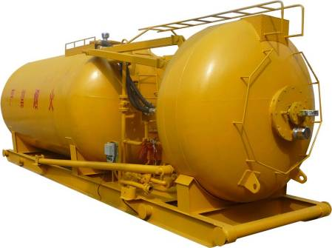
柴油罐是油田钻井钻机主要配套设备，主要是给发电机组储存和提供燃料。我公司设计生产的柴油罐操作简单，使用方便，易于维修。
Diesel tank is the major corollary equipment in oilfield drilling rig, it is mainly used to store and provide fuel to generator set. The diesel tank designed and produced by our company is easy and convenient to use and maintain.
柴油罐产品说明：
Diesel tank parameters
设计压力：  Design pressure | 常压  Ordinary pressure | 常用容积：  Common volume | 20m³、30m³、40m³、50m³  和60m³等。
使用温度：  Working temperature | ≤50° | 使用寿命：  Service life | 10年  10 years
执行标准：  Carried standard | 油罐按照：GB150-2011《钢制压力容器》标准设计制造。  罐的防腐按照：GB50393-2008《钢质石油储罐防腐蚀工程技术规范》  Oil tank is designed and manufactured according to GB150-2011 standard. The anti-corrosion of oil tank is according to GB50393-2008 standard.
罐体进行喷砂处理，防锈等级达到Sa2.5，使用加强级环氧煤沥青漆防腐。
涂层结构：底漆-中间漆-双层面漆，涂层总厚度不小于300μm。
Oil Tank is processed by sandblasting, antirust level can reach Sa2.5. Use intensive epoxy coal asphalt paint for anticorrosion.
Coating structure: primer-intermediate paint -double finish paint, the total thickness of coating is no less than 300μm.
二十七、振动筛网 Vibration screen mesh
板式振动筛网是目前最常用的一种石油振动筛网， 可广泛应用于不同条件下的钻井作业中。该产品通常由2到3层不锈钢网布粘合在开孔的金属衬板上构成。同时，筛网附带专用的橡胶塞以修补网面破损，可有效地节省时间，降低生产成本。我厂拥有丰富的生产经验和成熟的工艺，可根据不同客户的需求制造多种规格尺寸的勾边平板筛网。
Plate type vibration screen is one of the most frequent vibration screen,and be used in all kind of drilling operation.The screen is made of tow or three stainless steel meshes and metal backing with holes.We have a wealth of experience and mature technology in production,can also make creens according to customer requirements.
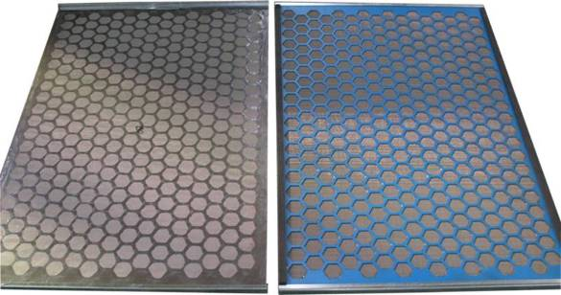
筛网型号  Screen type | 目数范围  Mesh No. | 尺寸  Dimension  （长×宽）(L×W) | 适配振动筛  品牌及型号  Shale shaker model | 质量（kg）  Weight
JSP-1 | 16-325 | 903×1155mm | SWACO,BEM-3 | 5.6
JSP-2 | 16-325 | 1212×1141mm | SWACO,ALS-11 | 9
JSP-3（PWP） | 16-325 | 697×1050mm | DERRICR FLC500 Series | 6
JSP-4（PWP） | 16-325 | 697×1053mm | DERRICKFLC2000 | 4.2
JSP-5 | 16-325 | 697×846mm | DERRICK,FLC313M | 4
JSP-6（PWP） | 16-325 | 915×1150mm | BRANDT LCM-20 | 8.6
JSP-7（PWP） | 16-325 | 720×1220mm | KEMTRON  KTL48 Series | 5.6
JSP-8（PWP） | 16-250 | 700×1165mm | 华油一机厂 S250 | 4.6
JSP-9 | 16-250 | 1186×1280mm | 华油一机厂 2X60 | 9.2

框架振动筛网是一种常用的石油振动筛网，主要由钢制框架和紧密结合在框架上的2到3层构成。该框不锈钢网布架由高强度方形钢管或扁钢焊接而成，并带有多条加强支撑筋，网布可通过金属衬板与框架结合，或直接粘合在框架上。每张筛网均附带专用的橡胶塞以修补网面破损。我厂可根据不同客户的需求制造多种规格尺寸的钢框架筛网。
Steel frame screens are mostly applied to the shale shakers with wedge fastening equipment. The screen frames adopt that high-strength square steel tube welded to multi-ribbed construction. They are sturdy and reliable. These screens are constructed with two or three stainless steel layers bonded to a steel support plank. Accessory rubber plugs may be used to repair rips or tears. By doing this, you can cut down time and reduce the production costs. We can also make creens according to customer requirements.
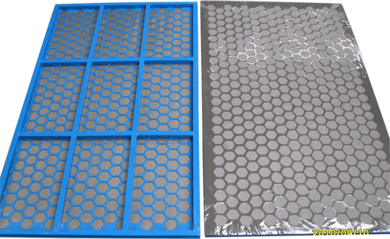

筛网型号  Screen type | 目数范围  Mesh No. | 尺寸  Dimension  （长×宽）(L×W) | 适配振动筛  品牌及型号  Shale shaker model | 质量（kg）  Weight
JSK-1 | 20-325 | 585×1165mm | SWACO  MONGOOSE | 12
JSK-2 | 20-325 | 635×1253mm | BRANDT BL-50 | 13.5
JSK-3 | 20-325 | 913×650mm | BRANDT  VSM-300 | 12.5
JSK-4 | 20-325 | 720×1220mm | KEMTRON  KTL48 Series | 17
JSK-5 | 20-325 | 712×1180mm | SF300 | 17
波浪式振动筛网的网面呈独特的波浪状，安装方式可以是勾边或钢框架网的楔形压紧装置。波浪网的有效滤过面积可达同一规格平板网的125%到150%，处理量因此大幅度提高。我厂能够根据不同客户的需求制造多种规格尺寸的波浪式筛网。
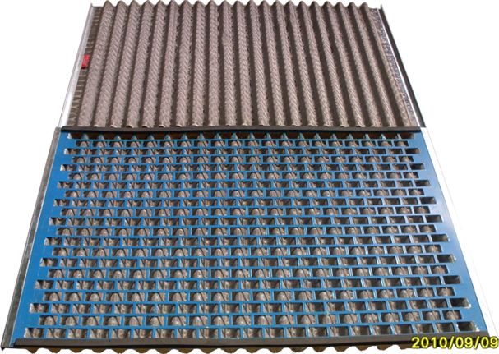
Awave vibration screen has a awave screen surface,installation type can be hook edge or steel frame.the area of the awave screen is up to 125%-150% of the same area plate type screen,and the capacity increases a lot.We can also make creens according to customer requirements.

筛网型号  Screen type | 目数范围  Mesh No. | 尺寸  Dimension  （长×宽）(L×W) | 适配振动筛  品牌及型号  Shale shaker model | 质量（kg）  Weight
JSB-1(PMD) | 80-210 | 635×1253mm | BRANDT,BL-50 | 17.5
JSB-2(PMD) | 80-210 | 697×1050mm | DERRICR  FLC 500 Series | 7.5
JSB-3(PMD) | 80-210 | 697×1053mm | DERRICR,FLC2000 | 5.8
JSB-4(PMD) | 80-210 | 915×1150mm | BRANDT,LCM-ZD | 10
勾边软式振动筛网的结构与平面板式筛网相似，通常仅由2层或三层不锈钢网布紧密粘合为一体构成，不带金属衬板。软网的有效过滤面积较平板网大、价格低，但寿命相对较短，需要根据具体的钻井作业条件选用不同的筛网。我厂能够根据不同客户的需求制造多种规格尺寸的平面软筛网。
Hook edge soft vibration screen has a same structure of plate type screen. The screen is usualy made of tow or three stainless steel meshes without metal backing.the area of soft screen is bigger than plate screen,and price is lower,but the service life is shorter. We can also make creens according to customer requirements.
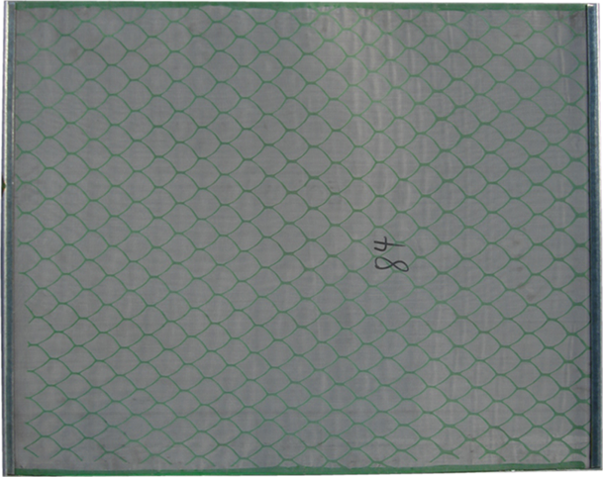

筛网型号  Screen type | 目数范围  Mesh No. | 尺寸  Dimension  （长×宽）(L×W) | 适配振动筛  品牌及型号  Shale shaker model | 质量（kg）  Weight
JSF-1 | 20-150 | 600×1040mm | 华油一机厂  NCS-300*2型 | 1.5
JSF-2 | 20-150 | 700×1165mm | 华油一机厂S250系列 | 2
JSF-3 | 120-210 | 1400×460mm | 华油一机厂ZCN系列 | 2.4
JSF-4 | 120-210 | 1000×1150mm | 华油一机厂NS-115/2 | 2.8
JSF-5 | 20-80 | 927×914mm | JSS（U.S.A） | 2.1
JSF-6 | 20-80 | 1219×1524mm | SSS(U.S.A) | 4.5

